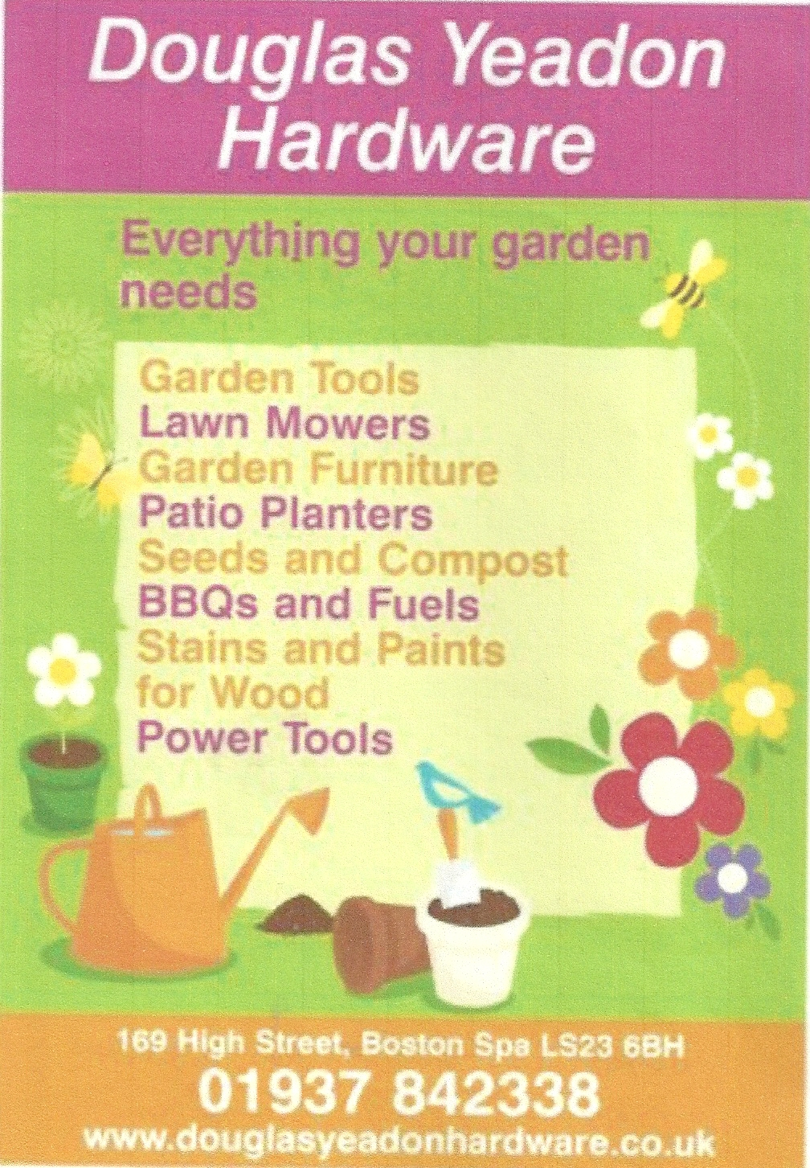
- Clifford 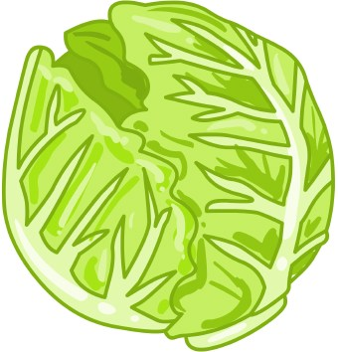
Village Show
(Open to non-residents)
2nd September 2023
In the Village Hall
2.00 - 4.00 pm
Announcement of winners at 3.15pm
Classes for:
Fruit and Vegetables • Flowers and Floral Art
Photography • Art and Handicrafts • Poems
Produce
Special Sections for:
Children and Teenagers
including a Diggle’s section
Refreshments
Plant Stall • Cake Stall
Charity No. 1186317
With thanks to Douglas Yeadon for their support

FRUIT AND VEGETABLES
[0n paper plates no bigger than 9’’/ 23cm diameter]
1. 12 raspberries; stalks on
2. 3 eating apples, any one variety
3. 3 cooking apples.
4. A plate of any other fruit.
5. 3 potatoes
6. 3 carrots
7. 3 onions, skin on
8. 6 beans, any variety/type [with stalk]
9. 2 sweetcorn
10. 3 courgettes.
11.6 tomatoes [stalks on]
12.3 beetroots with tops on.
13.A garlic bulb
14. 3 chilli peppers

The following don’t need a plate.
15.A cabbage any variety.
16. A cucumber
17. The longest bean
18. The heaviest onion with 1’’ stalk.
19. The heaviest marrow or squash.
20. 3 dressed onions.
21. A squash/pumpkin, any type
22. Box/Tray of 6 different vegetables.

FLOWERS
[Please keep the container simple]
23. A vase of herbs, 4 different kinds.
24. A vase of mixed sweet peas.
25. A vase of mixed GARDEN flowers, non-woody.
26. A miniature display of garden flowers in a wine glass.
27. 3 dahlias, each different
28. A vase of mixed roses, any type
29. The largest sunflower head.

FLORAL ART

30. An Ikebana style arrangement.
See below for more information.
- Space allowed for the entry must be no more than 20’’ long and 24’’ high
[50x 60 cm]
- Foliage and flowers need not have been grown by the exhibitor
- Entries should be constructed before bringing to the hall.

PHOTOGRAPHY
[Photographs should be no more than A4 / 30cm x 21 cm and simply mounted]
31. Flowers in all their glory.
32. The beauty of water.
33. Daily life in Yorkshire.

ART AND HANDICRAFTS
[Artwork no bigger than 24 x 24’’ 60 x 60cm. Picture sizes excludes any mount]
34.Painting, any medium: ‘Where the wild things are’
35.Artwork; Drawing and or sketching with or without colour; ‘A view from my window.’
36. A picture with a Nautical theme using collage/mixed media/thread.
37. A knitted or crochet item.
38. An item using patchwork.
39. Recycle items into something new to wear.
40. A poem: Theme; ‘What makes my heart sing’

PRODUCE
[All jars to be approx. 400gms or 1lb]
41. 1 jar of jam of any fruit
42. 1 jar of lemon curd.
43. 1 jar of fruit jelly
44. 1 jar of marmalade
45. 1 jar of chutney.
.

Produce Continued;
46.6 Feta and Sundried scones.
47. 6 Viennese biscuits part dipped in chocolate.
48. A jam Swiss Roll using 3 eggs.
49. A Yorkshire Curd Tart about 8’’/20cm.
50. Technical Challenge; Irish Soda Bread.
51. A bottle of flavoured spirit labelled with type.
52. A bottle of homemade wine labelled with type.

53. Apple Crumble Cake.
150g butter or vegetable margarine, 150g light brown sugar, 125g SR flour plus 50g ground almonds and a flat tsp. Baking Powder.
3 eggs, cinnamon and mixed spice.
Use the all-in-one method or the creaming method. Peel and chop about 400g of either cooking apples or eating apples, toss in lemon juice and some cinnamon.
Crumble Topping. 100g plain flour, 75g butter and 50g light brown sugar. Rub together.
Use a 23cm approx. loose bottomed cake tin,
greased and lined with a circle of baking parchment. Put the cake batter in the tin, cover with the prepared apples and sprinkle on the crumble. Cook for about 1 to 1½hours at 160C/ Reg 3. Cool in the tin for 10mins before removing.

54. MEN ONLY. A cake using vegetables as a main ingredient.

CHILDREN’S AND TEENAGERS’ CLASSES

Group A. Age 6 and under.
55. 4 decorated buns fit for a king.
56. A miniature garden in a seed tray.
57. Diggles Entry; Artwork of your favourite fantasy animal. Any medium.

Group B. Age 7 to 10.
58. 6 decorated buns fit for a king with 3 different designs.
59. A miniature garden in a seed tray.
60. A decorated plant pot holder using recycled materials or a recycled container.
61. A photograph using one of the titles in the Photography section above.
62. A poem ‘How to be an Eco Hero’
63.Diggles Entry; Artwork; Painting/ Drawing/ Collage ‘Save the Earth’ poster.
.

Group C. Age 11 to 16
64. Make and decorate a celebration cake fit for a king.
65. A cushion or a bag made out of scrap/recycled materials.
66. A photograph using one of the titles listed in the photography section above.
67. A poem, ‘How to be an Eco Hero’.
68.. Diggles Entry; Artwork; Painting/ Drawing/ Collage ‘Save the Earth’ poster.

PLEASE NOTE. We need donations for the Plant and Cake stall. Please bring them to the Village Hall on the morning of the show

RULES 2023
Anyone can enter. You do not need to live in Clifford to make an entry.
Competition Entries; 50p for each individual entry.
Children and Teenagers up to 16; 20p each entry.
- Entry forms AND payment must be put in an envelope and put through the letterbox of either
24 Albion Street or 4 Mill Dam, Clifford, by Monday 28th August.
- All entries must be made/grown by the exhibitor unless otherwise stated.
- No items previously exhibited at another show should be submitted.
- All entries must be taken to Clifford village hall between 9am and 10.30 am on the
day of the show. Judging will begin at 10.30 am.
- All exhibitors must provide their own plates and vases/containers etc.
The committee will not be responsible for any breakages.
- All names on exhibits must be covered for judging purposes. We suggest plates, jars and containers
have your name on the bottom and pictures/photos have names on the back
and other items have a luggage type label attached.
- An exhibitor may enter as many individual categories as they wish
but only the top 6 placings will be counted for the overall achievement award.
- First, second and third certificates will be awarded for all sections. Medals are awarded
for 1st places in the children’s and teenagers’ classes.
- Diggles First Fruits will award prizes and certificates for their sections.
- Cups or shields are awarded for overall achievements in the various sections and a
cup for the most points achieved overall.
- The judge’s decisions will be final.
- Where there is only one entry in a class the judges will make a decision whether to award a
certificate or not.
- The show committee is empowered to settle any dispute which may arise for which
the rules do not provide.
- All entries are to be left in the village hall until after the announcement of winners. After this, entrants may
- collect their entries.
- Any items not collected by 4.45pm will be dealt with as the committee decides.
- The Village Hall will be open to the public to view entries from 2.00 pm.

ADMISSION in the afternoon; Entrants FREE, Adults £1.00. Children Free.

ENQUIRIES TO Jane Davies 07802 447272; janedavies383@btinternet.com
PLEASE CHECK THE RULES OF ENTRY BEFORE YOU HAND IN THIS FORM



